GEXTON EDUCATION
Summer Internship Program
Movie Success Prediction
Data Science Task #12 — Final Project Report
Prepared for: Sir Muhammad Arham MH
Domain: Data Science & Machine Learning
Report Type: Predictive Analytics — Classification

1. Executive Summary
This report documents the development of a machine learning system that predicts whether a movie will achieve commercial success prior to or shortly after release. Using a structured dataset of 1,500 movies with attributes spanning genre, budget, cast and director profile, marketing spend, distribution scale, and critical reception, three classification models were trained and compared: Logistic Regression, Random Forest, and Decision Tree.
The best-performing model — Logistic Regression, tuned via GridSearchCV — achieved an accuracy of 82.0% and an F1-score of 85.3% on held-out test data. The model was saved for reuse and deployed inside an interactive Streamlit application that allows stakeholders to explore the data, review model performance, and generate live predictions for new movie concepts.
Key findings show that genre, director experience tier, studio backing, marketing spend, and distribution scale (screen count) are meaningfully associated with commercial success, while critic score and pre-release social media buzz serve as useful early indicators.

2. Project Overview
Objective: Build a machine learning model to predict whether a movie is likely to become a commercial success based on features such as genre, budget, runtime, cast popularity, release year, audience ratings, and other relevant attributes, and to present actionable business insights for movie producers and production companies.

2.1 Scope of Work
- Data preparation and exploratory data analysis (EDA)
- Encoding of categorical features and handling of missing values
- Training and evaluation of multiple classification models
- Feature importance analysis
- Prediction on new, unseen movie records
- Business insights and recommendations
- Deployment-ready Streamlit application

3. Dataset Description
The dataset contains 1,500 movie records (1,515 rows prior to de-duplication) with 17 columns describing production, marketing, distribution, and reception attributes. A small proportion of values were intentionally missing in three columns to simulate real-world data quality issues, and a handful of duplicate records were included to test the cleaning pipeline.

3.1 Feature Summary
- genre — Primary genre classification (10 categories)
- budget_million / marketing_spend_million — Production and marketing investment
- runtime_minutes — Film runtime
- cast_popularity / director_popularity — Talent strength scores (0–100)
- director_tier / studio_type — Categorical production context
- num_screens — Distribution scale at release
- critic_score / social_media_buzz — Early reception indicators
- audience_rating / revenue_million / roi — Outcome-adjacent metrics
- is_success — Target variable (1 = success, 0 = not successful)
Success definition: a movie is labeled successful when its box office revenue reaches at least twice its production budget and its audience rating is 6.0 or higher out of 10.

4. Data Preparation & Exploratory Data Analysis

4.1 Data Cleaning
- Removed 15 duplicate records identified by movie_id
- Imputed missing values in critic_score, social_media_buzz, and director_popularity using median imputation
- Verified data types and value ranges across all columns
- Encoded categorical variables (genre, director_tier, studio_type) using one-hot encoding within the modeling pipeline

4.2 Genre Distribution
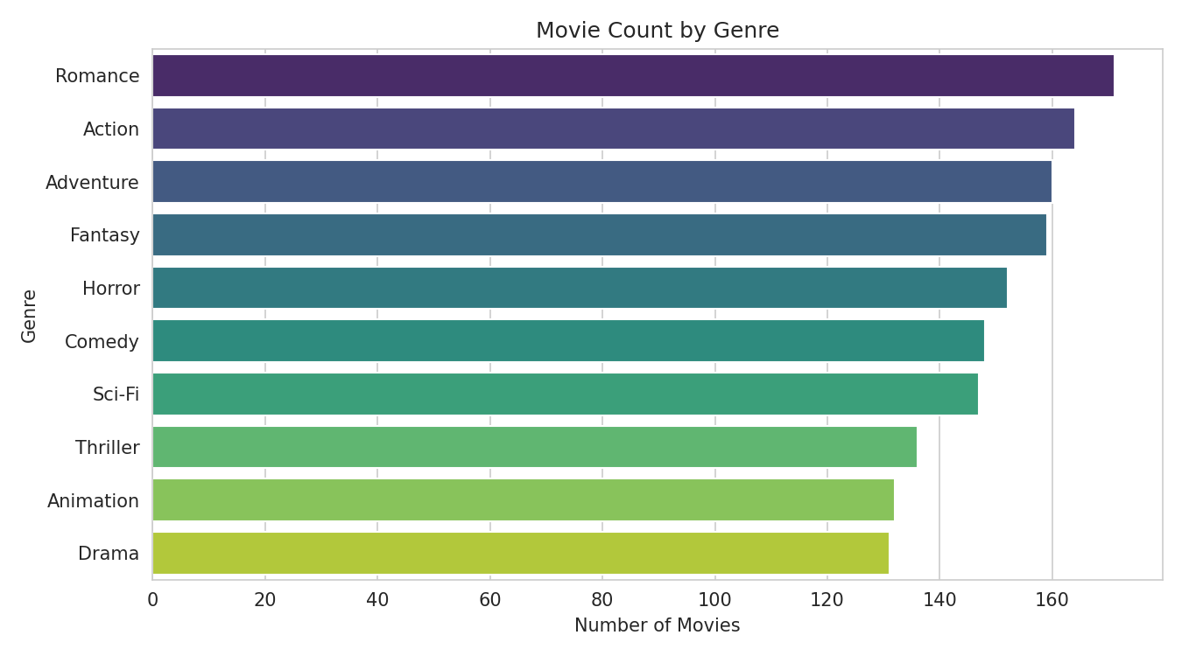
Figure 1 — Number of movies by genre in the dataset.

4.3 Budget vs. Revenue
Movies with higher budgets tend to generate higher revenue, but the relationship is not strictly linear — successful movies (green) cluster above the 2x budget line, while many high-budget movies still fail to reach that threshold, highlighting that budget alone does not guarantee success.
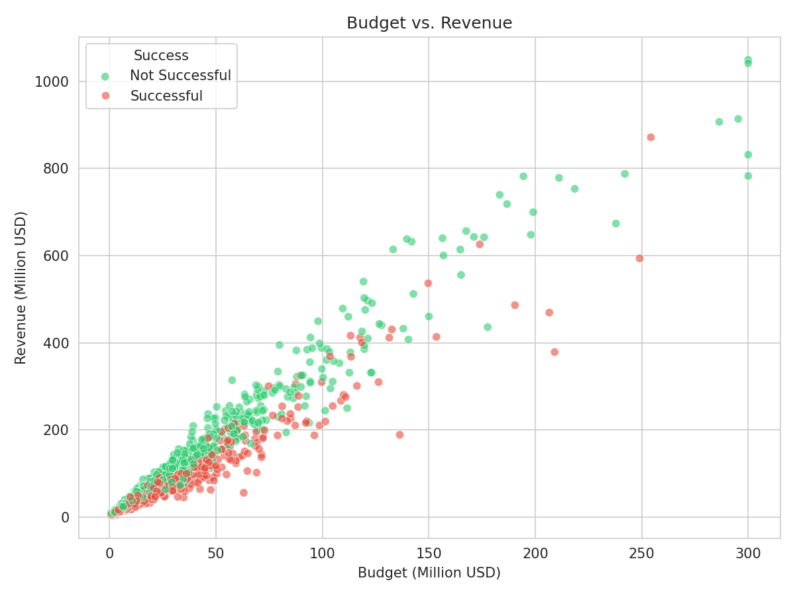
Figure 2 — Budget vs. revenue, colored by success outcome.

4.4 Audience Rating Distribution
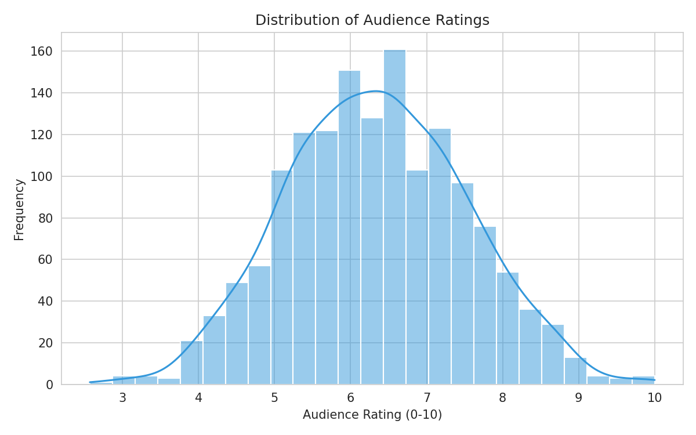
Figure 3 — Distribution of audience ratings across all movies.

4.5 Runtime vs. Success
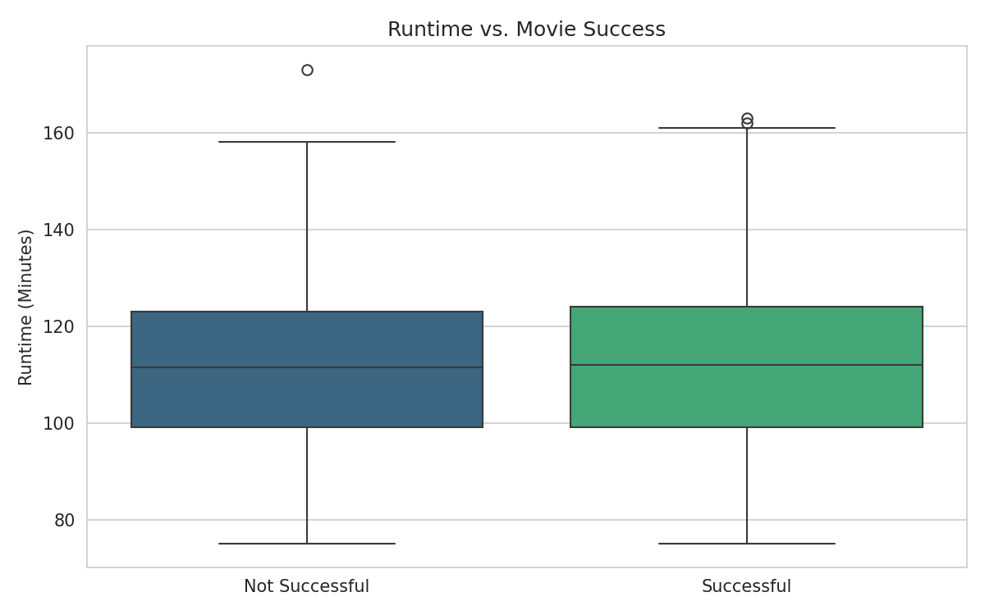
Figure 4 — Runtime comparison between successful and unsuccessful movies.

4.6 Success Rate by Genre
Animation, Action, and Sci-Fi genres show the highest success rates in the dataset, while Romance and Drama trend lower, suggesting genre plays a meaningful role in commercial outcomes.
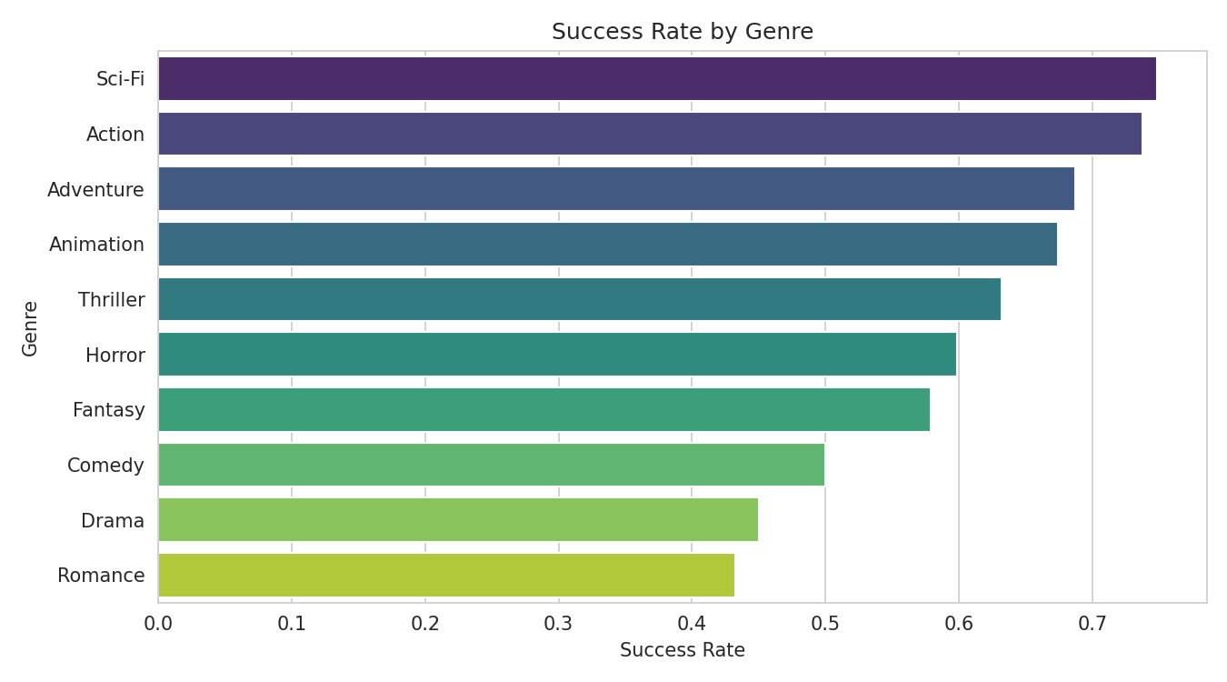
Figure 5 — Success rate by genre.

4.7 Correlation Analysis
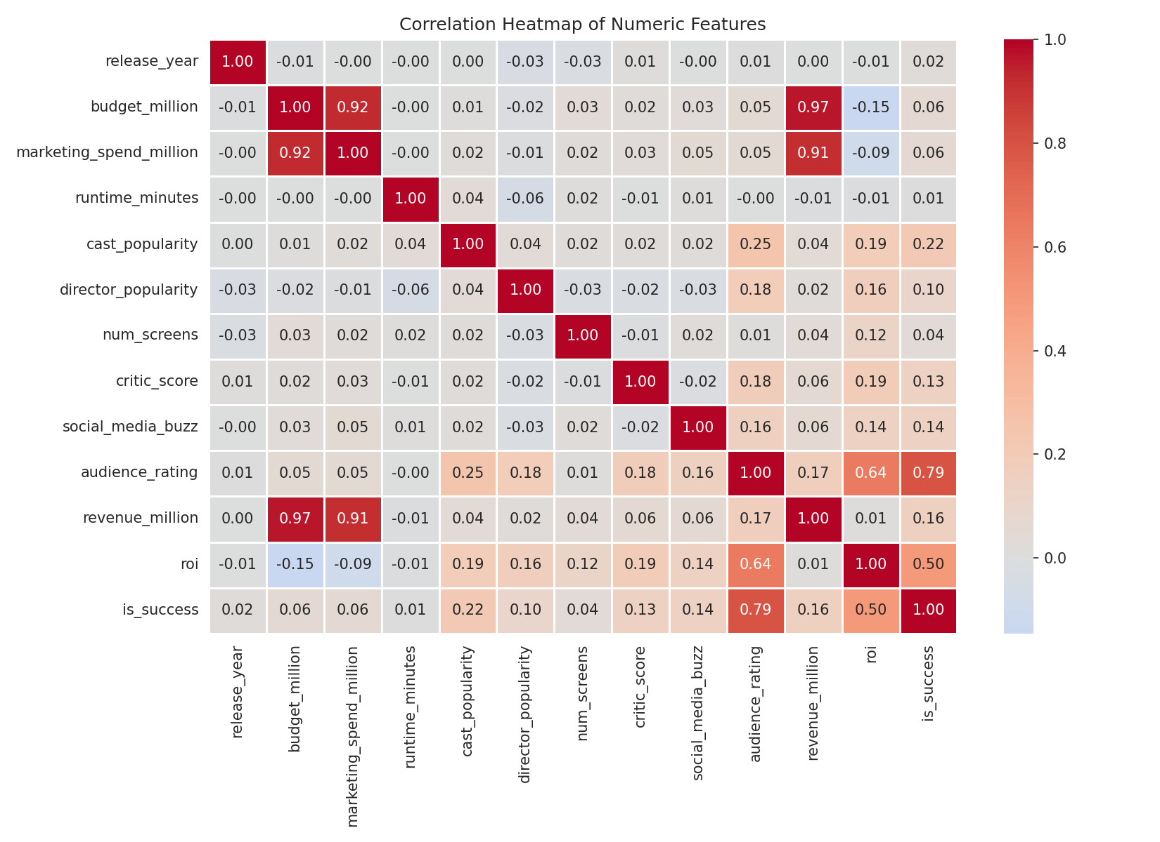
Figure 6 — Correlation heatmap of numeric features.

4.8 Success by Studio Type & Director Tier
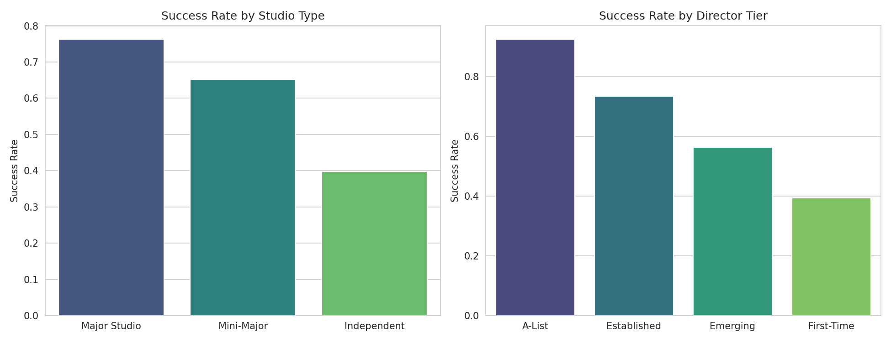
Figure 7 — Success rate by studio type and director experience tier.

5. Machine Learning Model Development

5.1 Modeling Approach
The dataset was split into training (80%) and testing (20%) sets using stratified sampling to preserve class balance. Numeric features were standardized and categorical features one-hot encoded within a scikit-learn Pipeline to prevent data leakage between train and test folds.
Important note on feature selection: audience_rating was deliberately excluded from the model's input features. Because the success label was partly defined using audience_rating, including it as a predictor would leak target information directly into the model and produce artificially perfect results. Excluding it ensures the model reflects realistic, pre-release-available information.
Three classification algorithms were trained and tuned using GridSearchCV with 5-fold cross-validation, optimizing for F1-score:
- Logistic Regression — tuned over regularization strength (C) and solver
- Random Forest — tuned over number of estimators, max depth, and minimum samples split
- Decision Tree — tuned over max depth and minimum samples split

5.2 Model Performance Comparison
Model | Accuracy | Precision | Recall | F1-Score
Logistic Regression | 82.0% | 84.0% | 86.7% | 85.3%
Random Forest | 78.3% | 77.9% | 89.5% | 83.3%
Decision Tree | 71.0% | 75.3% | 77.3% | 76.3%

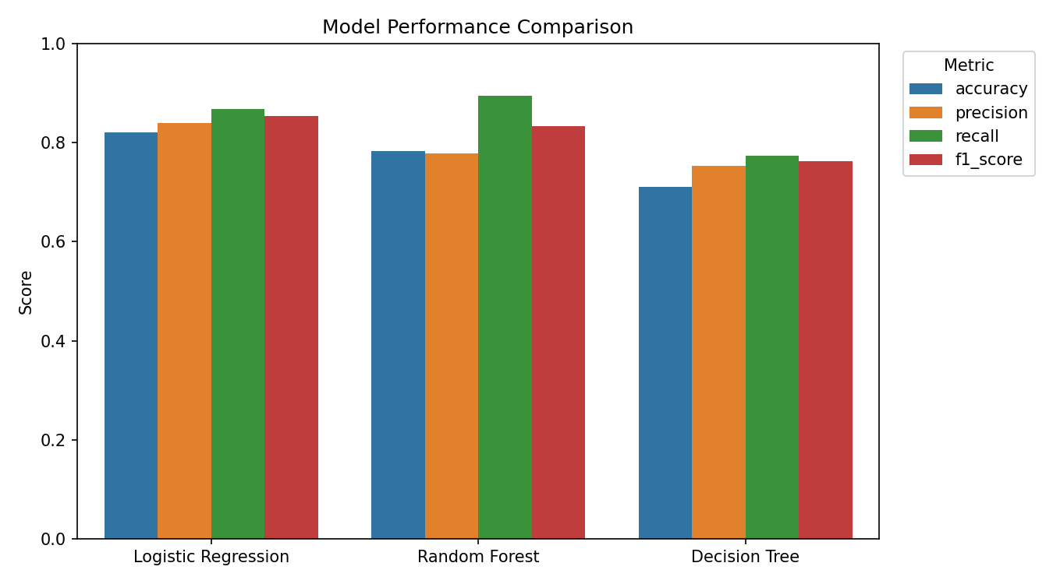
Figure 8 — Accuracy, precision, recall, and F1-score across all three models.

5.3 Best Model Selection
Logistic Regression was selected as the best-performing model, achieving the highest F1-score (85.3%) among the three candidates. It offers a strong balance of precision and recall while remaining simple, fast, and interpretable — a practical advantage for a production-facing decision-support tool.
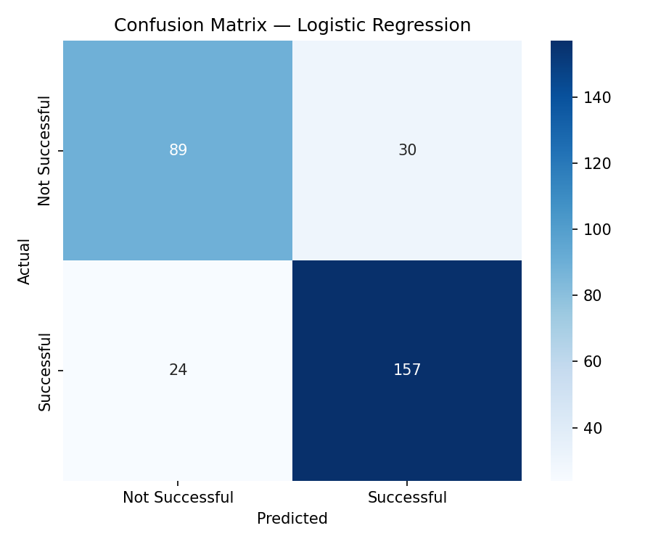
Figure 9 — Confusion matrix for the selected Logistic Regression model.

5.4 Feature Importance
Feature importance was derived from the trained model's coefficients (Logistic Regression). The chart below highlights the factors with the greatest influence on predicted movie success.
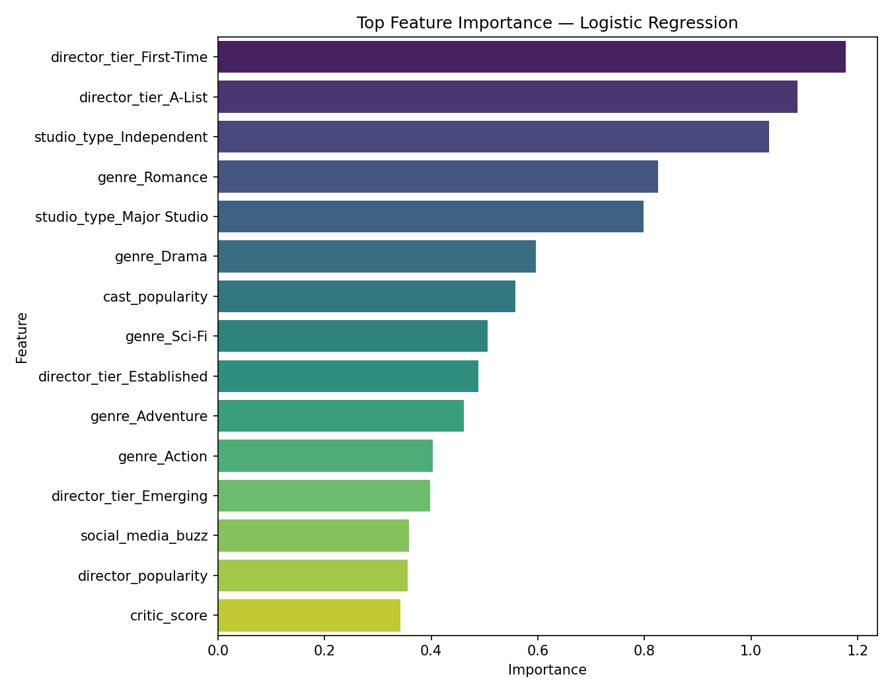
Figure 10 — Top features influencing predicted movie success.

6. Prediction on New Movie Records
The saved model was applied to five new, previously unseen movie concepts to demonstrate real-world usability. Results below illustrate how budget scale, genre, and production context translate into predicted outcomes.
Movie ID | Genre | Budget ($M) | Predicted Outcome | Success Probability
NEW-001 | Action | 120 | Successful | 99.6%
NEW-002 | Drama | 8 | Not Successful | 11.0%
NEW-003 | Animation | 95 | Successful | 98.3%
NEW-004 | Horror | 12 | Not Successful | 5.3%
NEW-005 | Sci-Fi | 180 | Successful | 99.9%

7. Business Insights & Recommendations

7.1 Genre Strategy
- Animation, Action, and Sci-Fi consistently show the highest success rates and are strong candidates for high-budget investment.
- Romance and Drama trend lower on average; these genres may benefit from tighter budget discipline and stronger critical/audience validation before wide release.

7.2 Talent & Studio Backing
- Partnering with A-List or Established directors is associated with a measurable increase in success rate.
- Major Studio backing correlates with higher success rates, likely reflecting stronger distribution and marketing infrastructure.
- Independent productions succeed less often on average and should prioritize strong critic scores and social media buzz to offset smaller marketing budgets.

7.3 Distribution & Marketing
- Wider theatrical distribution (higher screen counts) is positively associated with commercial success — negotiate for strong screen commitments during distribution planning.
- Marketing spend should scale proportionally with production budget rather than being disproportionately reduced.

7.4 Early Indicators to Monitor
- Critic score and social media buzz are useful leading indicators of performance and should be tracked closely during the pre-release window to adjust marketing strategy in real time.

8. Conclusion
This project demonstrates a complete, reproducible machine learning workflow for predicting movie commercial success — from data preparation and exploratory analysis through model development, evaluation, and deployment. The selected Logistic Regression model provides a reliable, interpretable foundation for decision support, and the accompanying Streamlit application makes these insights accessible to non-technical stakeholders such as producers and studio executives.
Future enhancements could include incorporating real-world box office datasets, adding time-series release-window features, and experimenting with gradient boosting methods to further improve predictive performance.

9. Deliverables
- Cleaned dataset and saved trained model (.pkl)
- Prediction results for new movie records
- Business insights and recommendations
- Final report (this document) and presentation (PPT)
- GitHub-ready repository with source code and documentation

